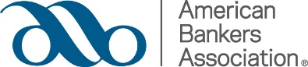

SAMPLE EMAIL

(Your Bank Name) is a member of the American Bankers Association, which means we all have access to ABA member resources and expertise. I use their resources frequently and find them very helpful in my role. ABA offers a wide range of resources, and they can help you, too.

I encourage you to go to ABA.com/GetStarted to start leveraging the resources. When you register for aba.com, you will have immediate access to all of their free resources including:

- ABA’s unparalleled staff experts at 1-800-BANKERS or accessible by using the online, searchable Experts on Call database. They also have a Compliance Hotline available to us, too.

- Resources for your specific job role. For example, in depth Compliance resources such as regulatory expertise, up-to-date reports on agency initiatives and the Compliance Network, an online discussion forum.

- Sign up for one or more of ABA’s 20+ specialized Email Bulletins on topics ranging from corporate governance and compliance to human resources and accounting.

This is just a partial list of what ABA has to offer – and they are always adding new resources for us – check out the latest additions. To learn more about what ABA can do for you, you can register for a free webinar that will show you how to fully take advantage of ABA. Alternately, you can reach out to Kim Michael at the ABA (kmichael@aba.com or 202-663.5203) who serves as our ABA concierge.

Sincerely,
(Your Name)

