**Hub and Spoke: More Than Facilities – It’s a Personnel Strategy**

Bankers often speak of hub and spoke branching models in the context of physical branch models – and that is one part of hub-and-spoke operations. But at its core, hub and spoke represents a personnel-driven operating model, from which different branch sizes are a beneficial consequence.

First, a definition, as hub and spoke joins CRM as banking jargon that we all discuss, but few define. Simply put, hub and spoke branching is an operating model wherein not all functions are offered by all branches with on-site personnel. Rather, while some branches (the hubs) continue to house the full array of officer functions on site, others (the spokes) rely on nearby branches to deliver more complex services, such as mortgage origination, business lending and wealth management.

Combining branches into clusters of geographically close branches allows only a single branch in the cluster to require an on-site officer for certain functions, with that officer serving all branches in the cluster. This then enables the spokes in the cluster to use smaller footprints.

But beyond that, there is an even more beneficial function to administer at the cluster rather than the individual branch level – branch management. Just as one mortgage officer or commercial lender can service multiple branches in close proximity, one manager can oversee multiple closely clustered branches. And in that case, benefits arise, not only from cost efficiencies but from improved sales effectiveness.

Consider an institution with 30 branches that geographically align into 10 clusters of three branches each. Especially in more constricted labor markets with significant competition for management-level employees, a bank or credit union may find it easier to hire 10 outstanding branch-cluster managers (perhaps at a 25% salary premium) than 30 adequate-quality branch managers.

In this or a similar scenario, the long-term reduction in noninterest expenses could transform the contribution level of an institution’s branch network. But more importantly, by concentrating sales authority in fewer managers, an institution could leverage the sales skills of its most effective managers across broader territories, allowing those senior officers to propagate their expertise to less-skilled colleagues.

Finally, the broader dominion accorded to the cluster managers can abet management retention, giving a career path for broader authority in a branch-management role, versus the ‘up-or-out’ model many banks and credit unions impose upon such officers.

The financial benefits from reconfiguration of staffing roles in such a scenario could prove substantial; though at some institutions, not all branches sit in close enough proximity to allow hub-and-spoke operations.

To the example of 30 branches parsed into 10 three-branch clusters: even with an elevation of salaries for the customer-service managers at the converted-spoke branches, the long-term reduction in noninterest expenses could transform the contribution level of the branch network, reducing salary expenses (not including benefits) by $1.2M annually across those 30 branches, at an average ratio of two spokes per hub (i.e., mostly three branch clusters).

As the table below illustrates, the savings assume elevating 10 branch managers from $80,000 to $100,000 per year; eliminating 20 other branch managers at $80,000 per year; and at those 20 branches where the branch manager position was removed, elevating a CSR to the role of customer-service manager, to yield the net $1.2M gain.

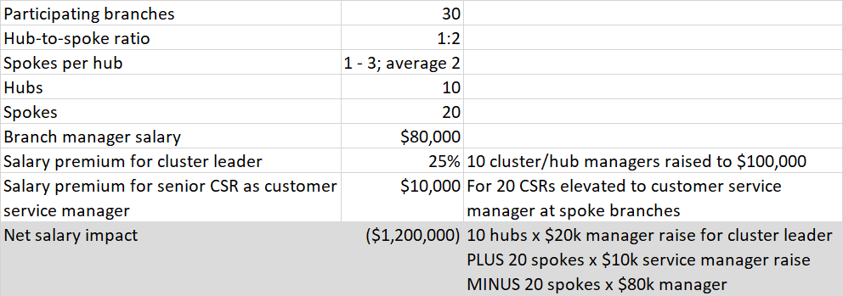

As the table shows, the financial gains from hub and spoke operations can be substantial, even for a mid-sized branch network. However, the most meaningful gains lie on the revenue side ‒ in leveraging the institution’s most effective branch managers, concentrating sales responsibility in those most effective at that process, and providing a career path and opportunities for salary gains that will help retain those top managers for lengthy careers.