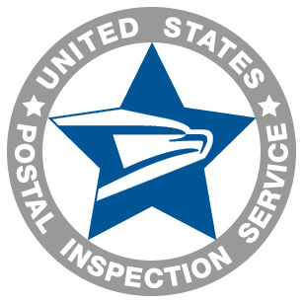

Intelligence Sharing Initiative (ISI) Membership Request

Please answer the following questions for access to the Intelligence Sharing Initiative website.

Provide the name, email address and phone number of the contact person for your business. Also indicate how you want your business to be listed on the website.

Please supply the names and email addresses of any additional members from your business.

How often does your business compile data regarding fraud addresses, fraudulent applications, ANIs, etc.? Provide dates, if possible.

Who in your business will be responsible for dropping this data into ISI?

Thank you in advance for your cooperation,

Joe Cronin
Postal Inspector, Program Manager
U.S. Postal Inspection Service
Criminal Investigations
(202) 268-6903
jwcronin@uspis.gov

Vickie McKnew
Program Specialist
U.S. Postal Inspection Service
Criminal Investigations
(202) 268-4296
vlmcknew@uspis.gov

