FOR GENERAL USE
Avoid Imposter Scams:
Toolkit for use June 15-26, 2026
The Elder Justice Coordinating Council’s Never EVER Campaign
for World Elder Abuse Awareness Day
#StopGovImposters
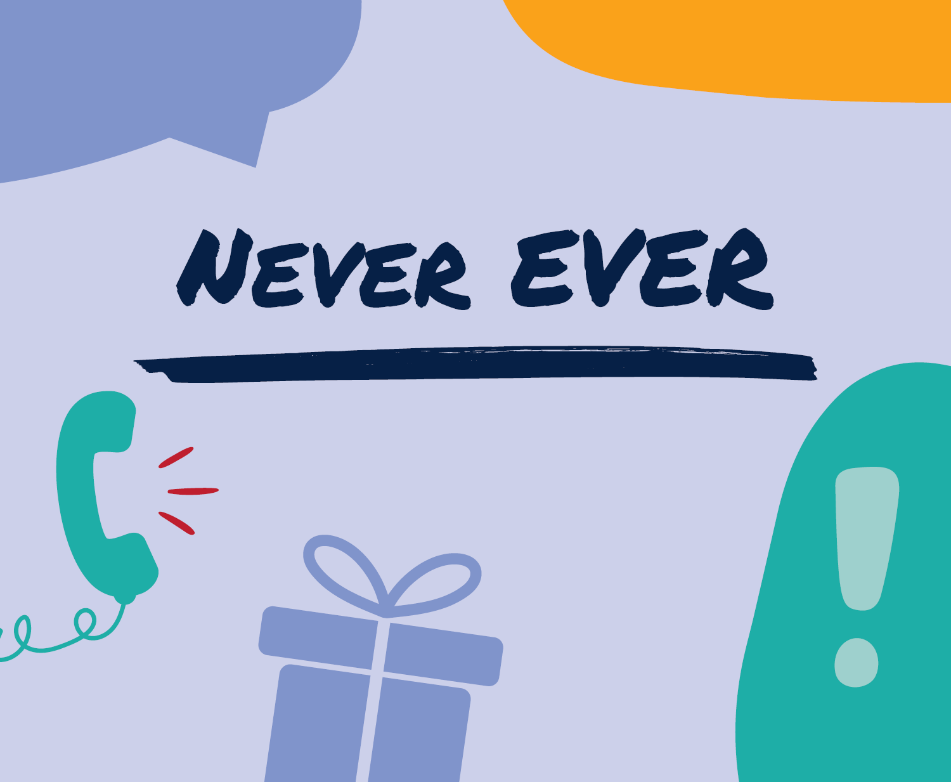
Toolkit components
1 Introduction 3
2 Timing and hashtag 3
3 Social media messages and graphics 3
4 Promotional blurb 6
5 Article 6
6 Website banners 8
7 Infographics 9
8 Radio and video scripts 11

- Introduction
World Elder Abuse Awareness Day (WEAAD) is June 15. WEAAD provides an opportunity for all of us to promote dialogue and action on the issue of elder abuse, neglect, and exploitation. This year, government agencies, businesses, and organizations across the country are joining together to help raise awareness about how to recognize and avoid imposter scams.
This toolkit has information and materials that any agency or organization can easily download, print, and share to help spread the word.
- Timing and hashtag
Please use and promote the campaign’s hashtag (#StopGovImposters) and other materials beginning June 15 through June 26.
- Social media messages and graphics
Find high-resolution versions of the graphics below in the accompanying folder. We don’t recommend copying and pasting the images below as they’ll be low-resolution.
- Social media post: We’re joining government agencies and organizations across the country to raise awareness about imposter scams. Learn the signs of an imposter scam so you can avoid them. #StopGovImposters ejcc.acl.gov/imposters
Graphic:
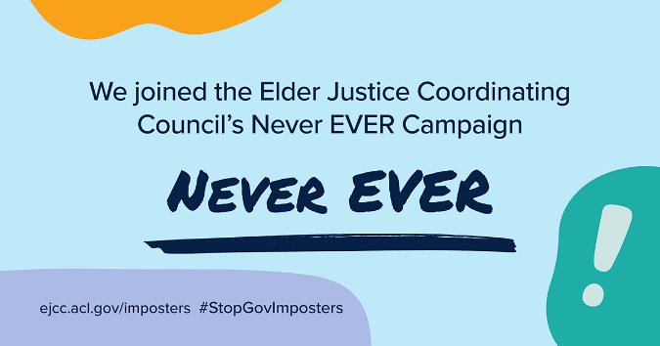
- Social media post: Did you see or experience an imposter scam? Report it at ReportFraud.ftc.gov. Your report makes a difference. #StopGovImposters
Graphic:
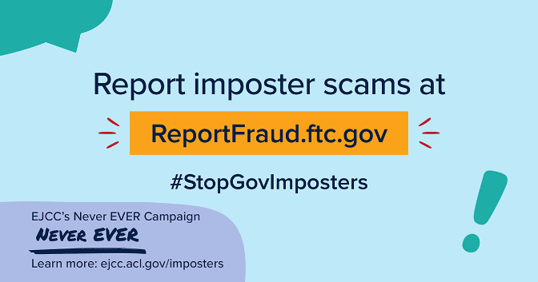
- Social media post: If someone says they’re from the government and tells you to move your money or put it in a federal locker, that’s an imposter scam. No one from the government will ever tell you that your money isn’t safe and you must move it to “protect it.” Only a scammer will. #StopGovImposters ejcc.acl.gov/imposters
Graphic:
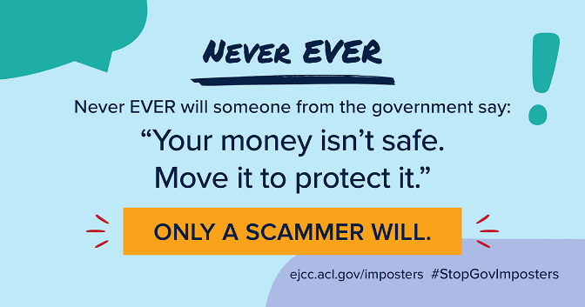

- Social media post: Did someone call, text, or email and say you have to pay the government immediately, in a specific way, or you’ll be in trouble? That’s a government imposter. No one from the government will ever demand payment only with gift cards, wire transfers, cryptocurrency, or a payment app. Only a scammer will. #StopGovImposters ejcc.acl.gov/imposters
Graphic:
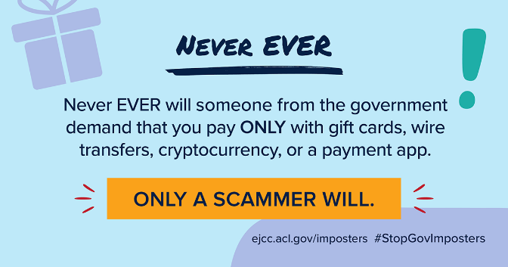
- Social media post: Did you get a call, email, or text message saying you might be eligible for a government grant or program? Nobody from the government will ever get in touch to demand your Social Security number to see if you qualify. Only a scammer will. #StopGovImposters ejcc.acl.gov/imposters
Graphic:
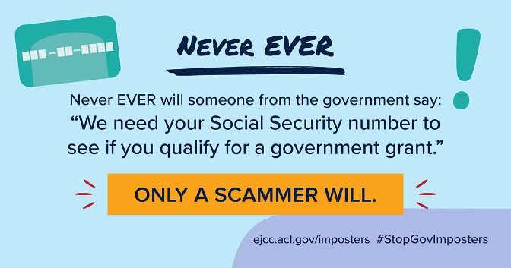

- Promotional blurb
Add this blurb to a newsletter, include it in an email blast, or post it on your website.
This World Elder Abuse Awareness Day, join government agencies and organizations nationwide to spread the word about imposter scams. These scammers pretend to be someone they’re not — including government agencies and well-known businesses — to trick you into giving them money, access to your financial accounts, or your personal information. Learn how to avoid these scams, and help spread the word, by joining the Elder Justice Coordinating Council’s Never EVER campaign. More at ejcc.acl.gov/imposters.
- Article
Use this article as a blog post, email blast, press release, or newsletter article.
Do you know how to spot a government imposter?
This World Elder Abuse Awareness Day, join the Elder Justice Coordinating Council, government agencies, and organizations across the country to spread the word about government and business imposter scams.
Government imposter scams are a serious problem: in 2025, the FTC received more than 375,000 reports about government imposters, with reported losses of $917 million.
These imposter scammers lie and pretend to be someone they’re not. Their goal? Trick you into giving them money, access to your financial accounts, or your personal information. They make up complicated stories about so-called emergencies so you’ll panic and act quickly before you have time to think about what to do or talk to someone you trust.
One common scam starts with an unexpected call from someone who says they’re from a well-known business, saying there’s suspicious activity on your account.
To “help” you, they transfer you to someone who says they’re from the government. This so-called helper, who claims to be from the FBI, the FTC, or some other law enforcement agency, urges you to move your money to “protect it” — maybe by transferring it to an account they give you, depositing it in a “government account” or crypto ATM for “safekeeping,” or getting cash or gold and giving it to a courier. But it’s all a lie. No one from the government will ever ask you to do these things. Only scammers will.
Other lies might involve a “suspended Social Security number” or supposed eligibility for government benefits. In all cases, that scammer will go to great lengths to convince you they’re with the government: fake caller ID or official-looking letters, for example. The agency name might be real or made up (but real-sounding), and some scammers might show you an employee ID or badge — all to seem more real. But they’re not.
To recognize and avoid a government imposter, keep these things in mind:
- Never ever will someone from the government say: “Your money isn’t safe. Move it to protect it.” Only a scammer will.
- Never ever will someone from the government threaten to suspend your government benefits if you don’t pay immediately. Only a scammer will.
- Never ever will someone from the government demand that you pay with a payment app, cryptocurrency, wire transfer, or gift cards.
Talk to someone you trust if you’re worried about a problem with your account or identity — especially if the stranger says they’re from the government or the situation is serious or involves a crime. Visit ejcc.acl.gov/imposters for more on imposter scams. And if you spot an imposter scam — or any other type of scam — report it at ReportFraud.ftc.gov.

- Website banners
Consider placing a banner or warning message on your home page, staff or employee biography-page sidebars, or other pages about imposter scams telling people what you or another organization, like the government, will never do. For example:
[Organization name] will never demand money, make threats, tell you to transfer money, or promise you a prize. If you’ve been targeted by a scam like this, report it at ReportFraud.ftc.gov.
[Organization name] will never threaten you, say you must transfer your money to “protect it,” or tell you to withdraw cash and give it to someone. Only a scammer will.

- Infographics
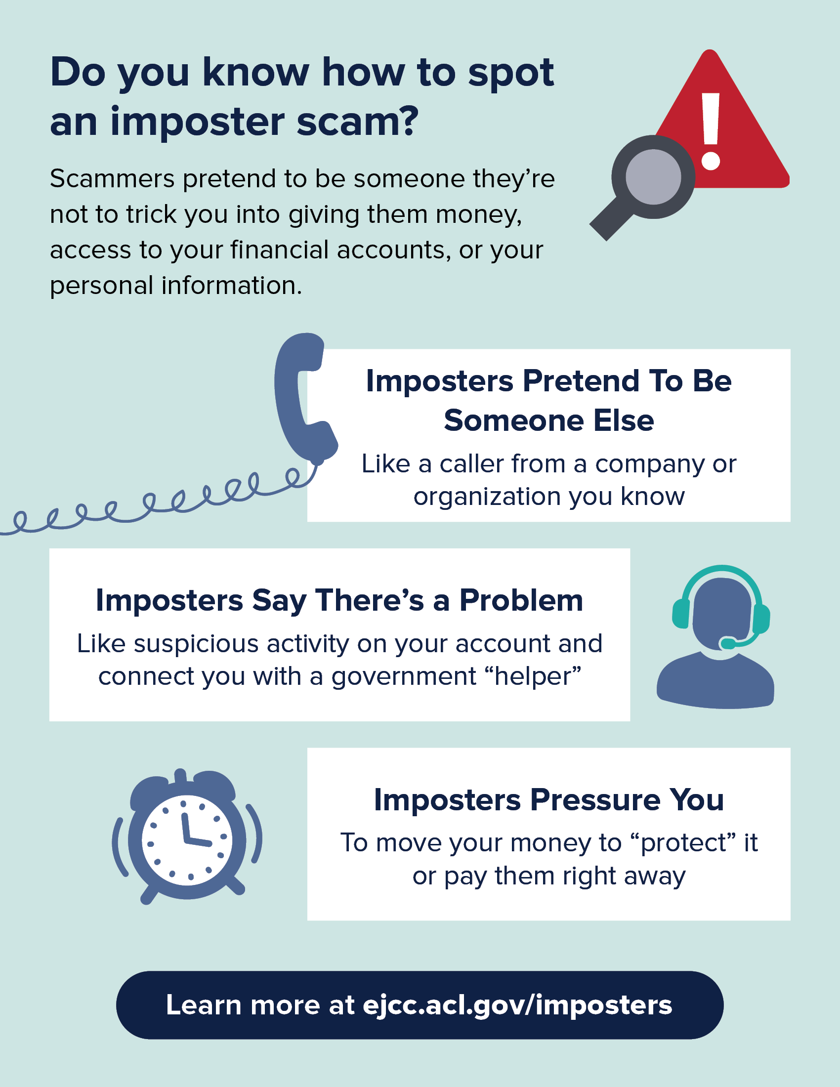
Post these infographics on your website, share them on social media, or include them in presentations you’re giving.
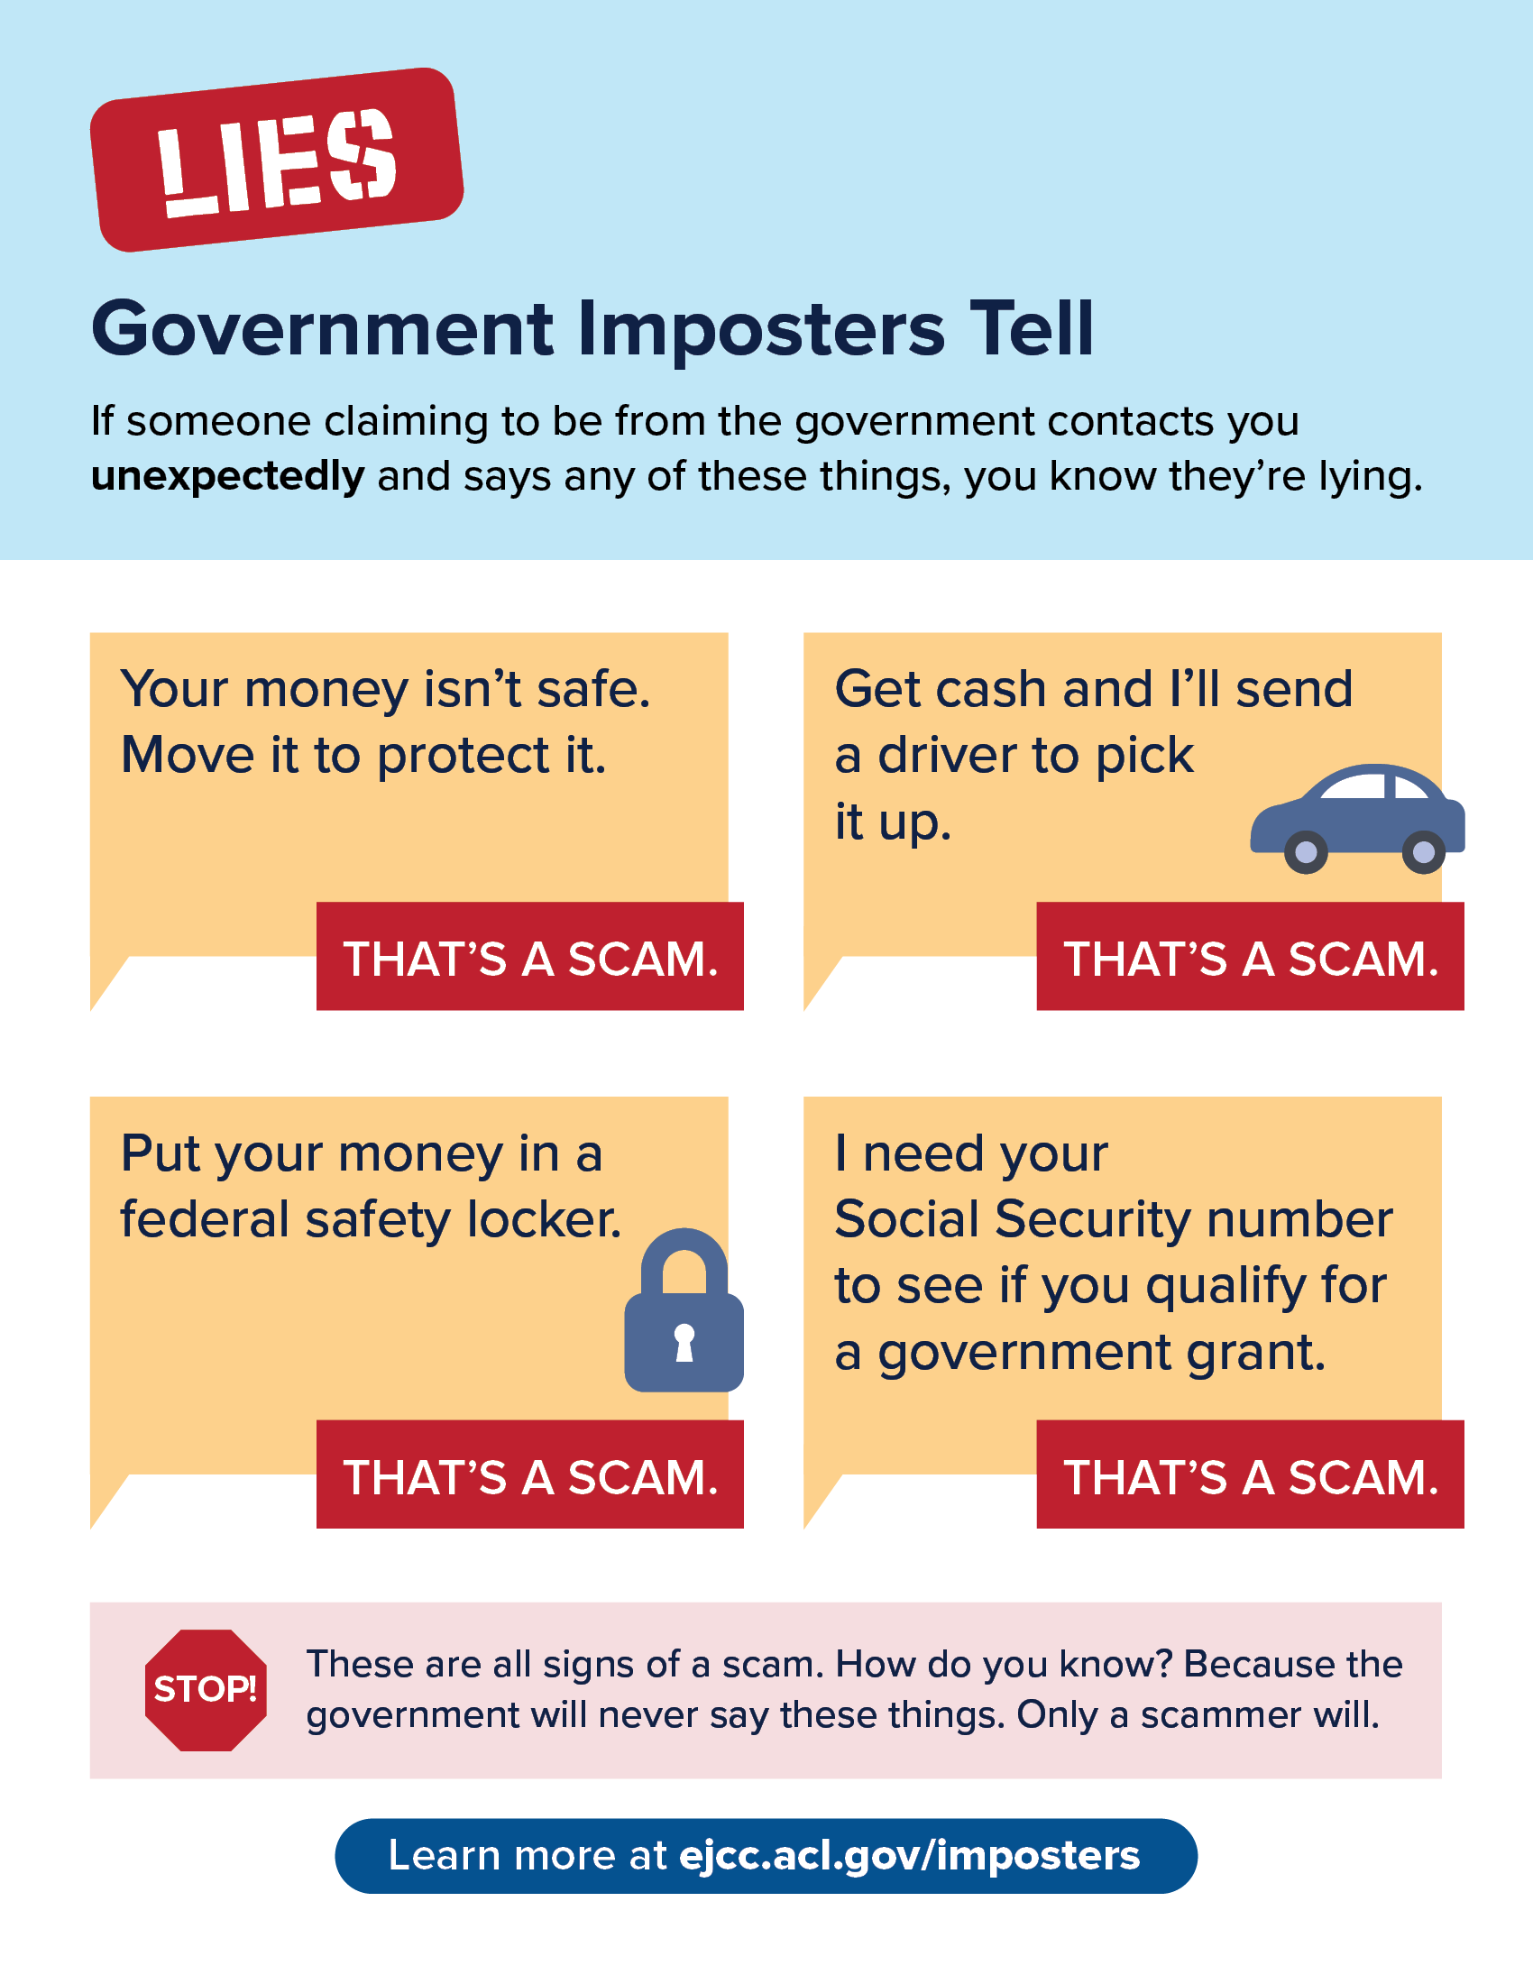

- Radio and video scripts
Consider recording a video with your company or organization’s leadership outlining what you or another organization, like the government, will never do. (We’ve also included potential scripts for radio.)
30-second video script
Hi, I’m [leader’s name] from [company or organization] and I want you to know: never ever will anyone from [organization name] get in touch, out of the blue, to demand money or personal information. We’ll never ever threaten you or tell you to move your money, supposedly to protect it. Only a scammer will do those things. So if you get a call or message like that, stop. Talk to someone you trust. And learn more at ejcc.acl.gov/imposters.
30-second radio script
Imagine a business calls about suspicious activity on your account. Is it really that business? They want to transfer you to a government agent to fix the issue…but who is that agent, really?
No matter how urgent the problem seems, stop. Talk to someone you trust. And check it out with the real business or agency — not whoever’s on the phone.
Because never ever will a real business or agency tell you to move money to protect it, send a courier, or demand payment only by crypto or bank transfer. Only scammers will.
Learn more at ejcc.acl.gov/imposters.
15-second radio script
Never ever will a real business or government agency tell you to move your money to protect it. They won’t send a courier to collect cash. They won’t tell you to buy crypto, or get a bank transfer while lying to the teller. Only scammers will. Learn more at ejcc.acl.gov/imposters.

###
For questions on the toolkit or campaign,
reach out to the FTC: Kira Krown (kkrown@ftc.gov)
and Gema de las Heras (gdelasheras@ftc.gov).

